**DAILY ONLINE ACTIVITIES SUMMARY**

|  |  |  |  |  |  |  |  |  |
| --- | --- | --- | --- | --- | --- | --- | --- | --- |
| **Date:** | **20-05-2020** | | | | | **Name:** | **Shrinivasa** | |
| **Sem & Sec** | **6th Sem B sec** | | | | | **USN:** | **4al17cs092** | |
| **Online Test Summary** | | | | | | | | |
| **Subject** | | **System Software and Compiler Design** | | | | | | |
| **Max. Marks** | | **30** | | **Score** | | | **21** | |
| **Certification Course Summary** | | | | | | | | |
| **Course** | **Machine Learning with Python** | | | | | | | |
| **Certificate Provider** | | | **Cognitiveclass.ai** | | **Duration** | | | **12 hours** |
| **Coding Challenges** | | | | | | | | |
| **Problem Statement:** | | | | | | | | |
| **Status: C**ompleted | | | | | | | | |
| **Uploaded the report in Github** | | | | | **Yes** | | | |
| **If yes Repository name** | | | | | <https://github.com/Shrinivasakunder/certification-and-online-coding> | | | |
| **Uploaded the report in slack** | | | | | **Yes** | | | |

Online Test Details: (Attach the snapshot and briefly write the report for the same)

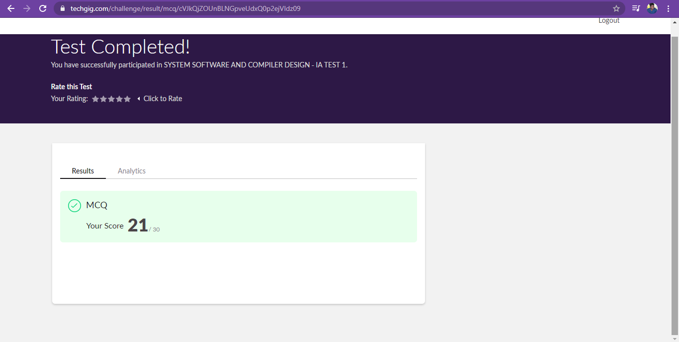

Certification Course Details: (Attach the snapshot and briefly write the report for the same)

**Progress on 20-05-2020**

* **Topic Completed Today**

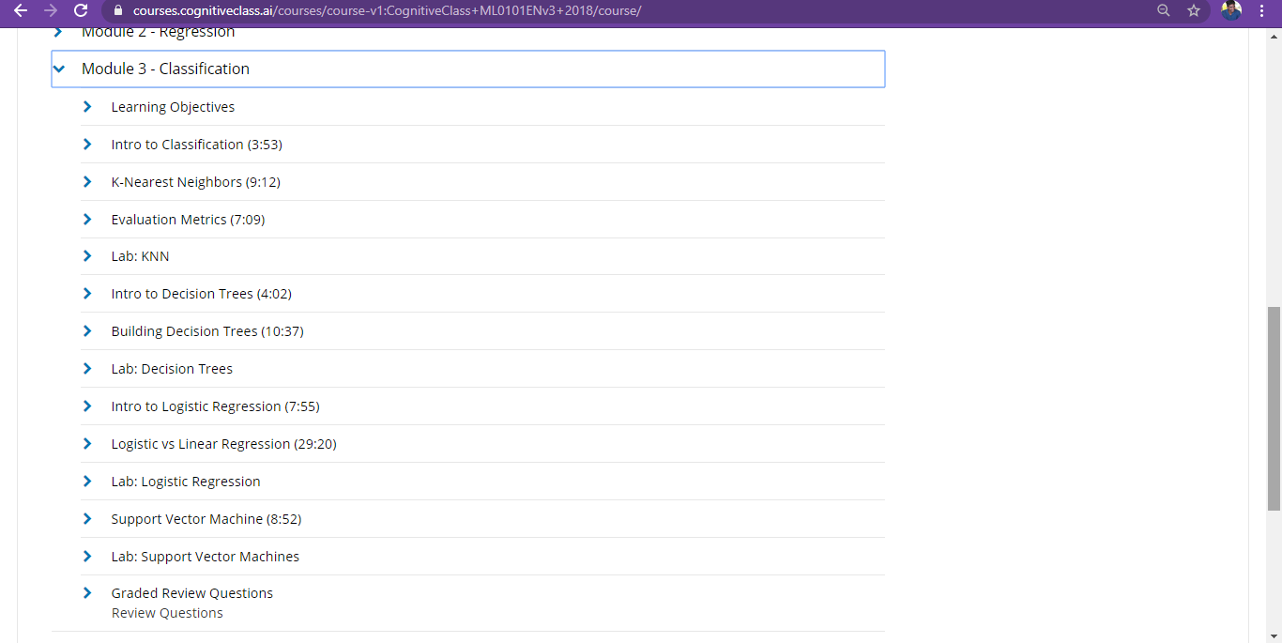

* **Progress Report**

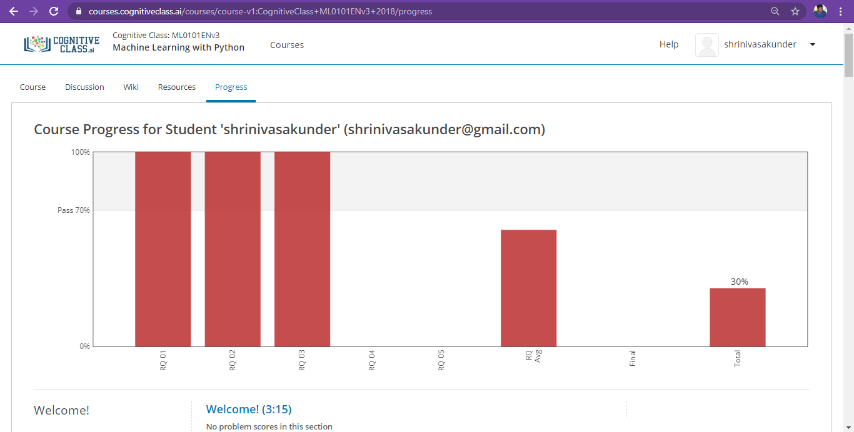

Coding Challenges Details: (Attach the snapshot and briefly write the report for the same)

<https://github.com/Shrinivasakunder/certification-and-online-coding>

